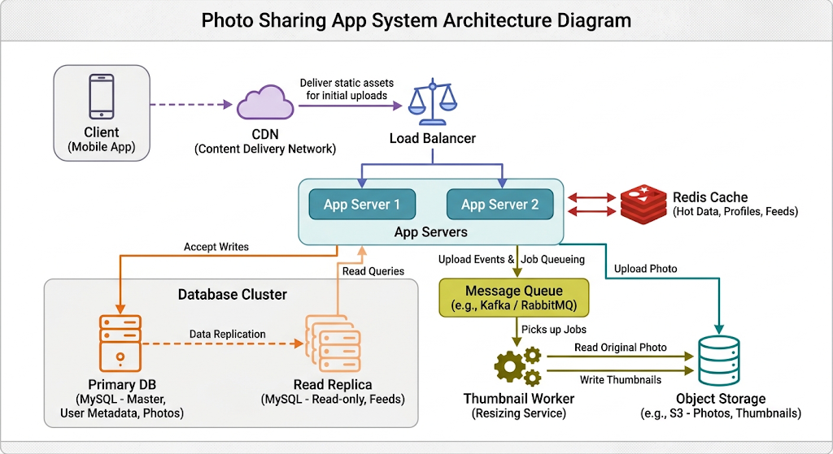

1. Assumptions & Daily Active Users (DAU)
- Registered Users: $10,000,000$
- Active User Rate: $10\%$ of registered users active per day
- Upload Activity: Each active user uploads $1$ photo per day.
- Feed Consumption: Each active user views $50$ feed pages per day.
- File Sizes: Average photo size is $2\text{ MB}$; generated thumbnail is $50\text{ KB}$ ($0.05\text{ MB}$).
- Time Basis: $1\text{ day}=86,400\text{ seconds}$.
DAU Calculation
$$\text{DAU}=10,000,000×10\%=1,000,000\text{ active users per day[cite: 1]}$$
2. Traffic and Storage Calculations
Uploads per Second (Writes)
- Average Uploads/sec:
$$\frac{1,000,000\text{ uploads}}{86,400\text{ seconds}}≈11.57\text{ writes/sec[cite: 1]}$$
- Peak Uploads/sec ($5×$):
$$11.57×5=57.85\text{ writes/sec}$$
Feed Views per Second (Reads)
- Total Daily Feed Views:
$$1,000,000\text{ users}×50\text{ views}=50,000,000\text{ views/day[cite: 1]}$$
- Average Feed Views/sec:
$$\frac{50,000,000}{86,400\text{ seconds}}≈578.7\text{ reads/sec[cite: 1]}$$
- Peak Feed Views/sec ($5×$):
$$578.7×5=2,893.5\text{ reads/sec}$$
Photo Storage per Year
- Daily Raw Photo Storage:
$$1,000,000×2\text{ MB}=2,000,000\text{ MB}=2\text{ TB/day[cite: 1]}$$
- Daily Thumbnail Storage:
$$1,000,000×0.05\text{ MB}=50,000\text{ MB}=0.05\text{ TB/day[cite: 1]}$$
- Total Daily Storage: $2.05\text{ TB/day}$
- Total Storage per Year ($365\text{ days}$):
$$2.05\text{ TB/day}×365=748.25\text{ TB/year[cite: 1]}$$

the system is read-heavy with a read-to-write ratio of roughly 50:1.
What a Read-Heavy System Means for Design:
- Aggressive Multi-Layer Caching:
  - Because reads vastly outnumber writes, hitting the database for every feed request would create severe bottlenecks.
  - The architecture prioritizes caching static assets (photos and thumbnails) at edge locations using a Content Delivery Network (CDN) and caching metadata/pre-computed feed timelines in memory using Redis.
- Read/Write Database Separation:
  - The primary relational database handles write transactions (such as new photo uploads, user profiles, and follow relationships).
  - High-volume feed reads are offloaded to Read Replicas, preventing feed-scrolling traffic from locking tables or exhausting connection pools on the primary database.
- Optimized Feed Generation Strategy:
  - Design choices favor fast read latency, such as pre-building user timelines asynchronously (fan-out on write) or maintaining active feed caches, ensuring sub-second response times when users open or refresh their feeds.

• Ferformance Degradation & Bloat: Storing large binary objects (BLOBs) directly inside a database rapidly increases the database file size, exhausts RAM buffer pools, slows down index lookups, and degrades overall query performance.
• Backup & Restore Bottlenecks: Large database sizes make point-in-time restores and regular backups impractically slow, complex, and expensive.
• Cost Inefficiency: High-performance database storage (SSD/NVMe optimized for transactional consistency and high IOPS) is significantly more expensive per gigabyte than scalable object storage.

Component Descriptions (One Sentence Each)
- CDN: Caches and serves high-resolution photos and thumbnails from edge locations close to users to minimize latency and reduce origin bandwidth[cite: 1].
- Load Balancer: Evenly routes incoming web traffic across stateless application servers to prevent single-point bottlenecks and ensure continuous availability[cite: 1].
- App Servers: Executes core application logic, handles authentication, routes file storage calls, and builds user feeds[cite: 1].
- Cache (Redis): Stores high-frequency data like user sessions, rate limits, and precomputed feed timelines in memory to provide low-latency responses[cite: 1].
- Primary Database: Manages transactional metadata writes for user profiles, photo records, and follower relationships[cite: 1].
- Read Replica Database: Asynchronously mirrors the primary database to serve high-volume read queries for feeds without stressing the primary database[cite: 1].
- Object Storage: Offers scalable and cost-effective storage for raw photo files and generated thumbnails[cite: 1].
- Message Queue & Worker: Asynchronously offloads image processing operations, such as thumbnail creation, from the main user-facing application thread[cite: 1].

Step-by-Step Photo Upload Flow
- Upload Initiation: The client app sends an HTTP POST request containing the image binary and photo metadata to the Load Balancer[cite: 1].
- Request Routing: The Load Balancer forwards the request to an available App Server[cite: 1].
- Raw File Persistence: The App Server writes the raw 2 MB image file directly to Object Storage and receives a storage URL[cite: 1].
- Metadata Insertion: The App Server saves a record (user ID, photo URL, caption, timestamp) into the Primary Database[cite: 1].
- Enqueuing Task: The App Server emits a "Generate Thumbnail" job containing the image URL to the Message Queue[cite: 1].
- Client Response: The App Server returns a 201 Created HTTP response to the client so the user is not forced to wait for processing to finish[cite: 1].
- Async Thumbnail Processing:
  - A Thumbnail Worker picks up the job from the Message Queue[cite: 1].
  - The Worker downloads the raw photo from Object Storage, resizes it into a 50 KB thumbnail, and saves the thumbnail back to Object Storage[cite: 1].
  - The Worker updates the photo metadata record in the database with the thumbnail URL[cite: 1].
8. System Trade-offs
- Fan-out on Write vs. Fan-out on Read (Feed Generation):
  - Trade-off: Pre-computing feed timelines when a user posts (Fan-out on Write) makes reading feeds almost instant, but consumes high storage and computing resources when high-follower users upload[cite: 1]. Conversely, assembling feeds on-the-fly when a user opens their app (Fan-out on Read) conserves storage but causes higher latency on feed loads[cite: 1].
- Asynchronous vs. Synchronous Thumbnail Generation:
  - Trade-off: Processing thumbnails asynchronously via background queues provides fast upload response times, but introduces temporary eventual consistency (the thumbnail won't appear instantaneously in the feed for a few seconds)[cite: 1]. Processing synchronously keeps data consistent immediately, but blocks the user's connection during file processing[cite: 1].
- Database Replication Lag:
  - Trade-off: Routing reads to database replicas offloads the primary database, but can lead to eventual consistency issues where a user uploads a photo and doesn't immediately see it on their feed if the replica hasn't synced yet[cite: 1].

